**Fourier Transform :**

1. **Generate a 2D sine wave image :**

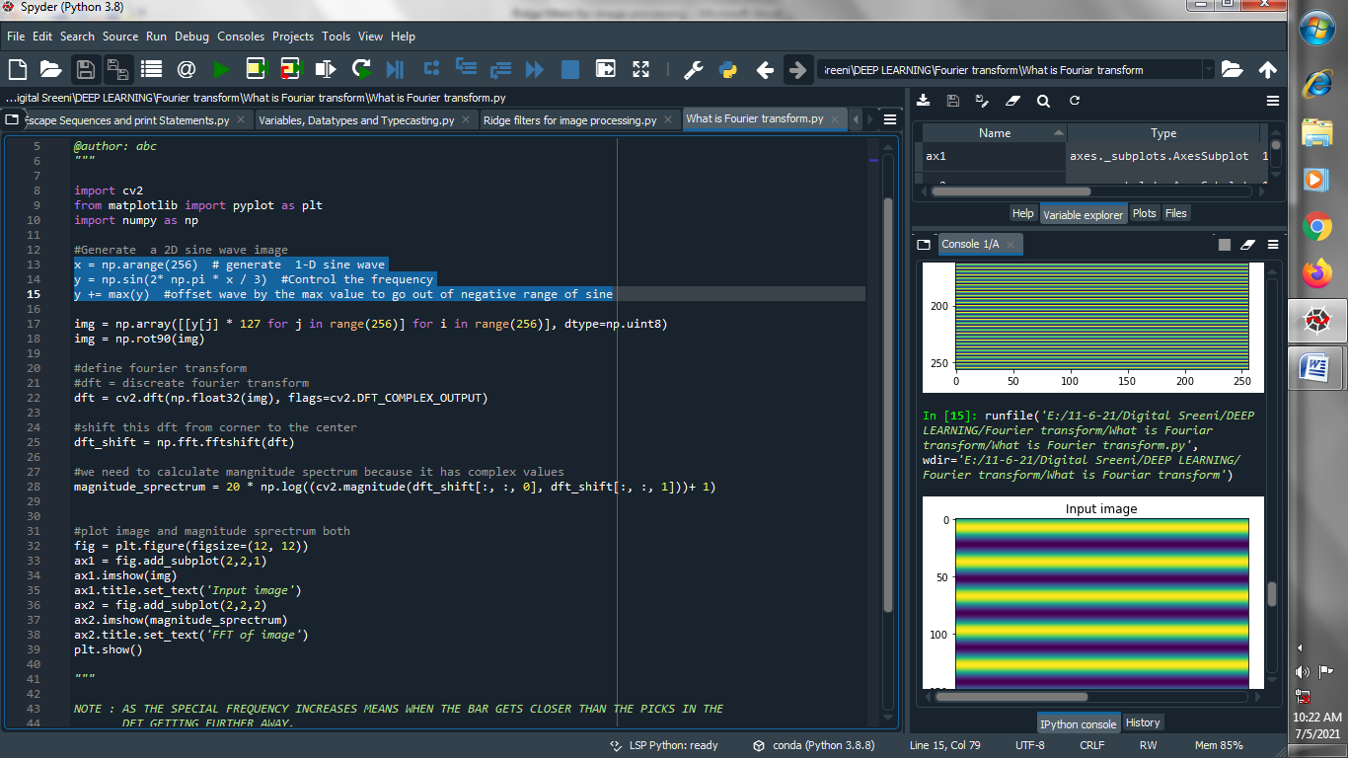

1. **Create an array of that image and scaling it and rotate :**

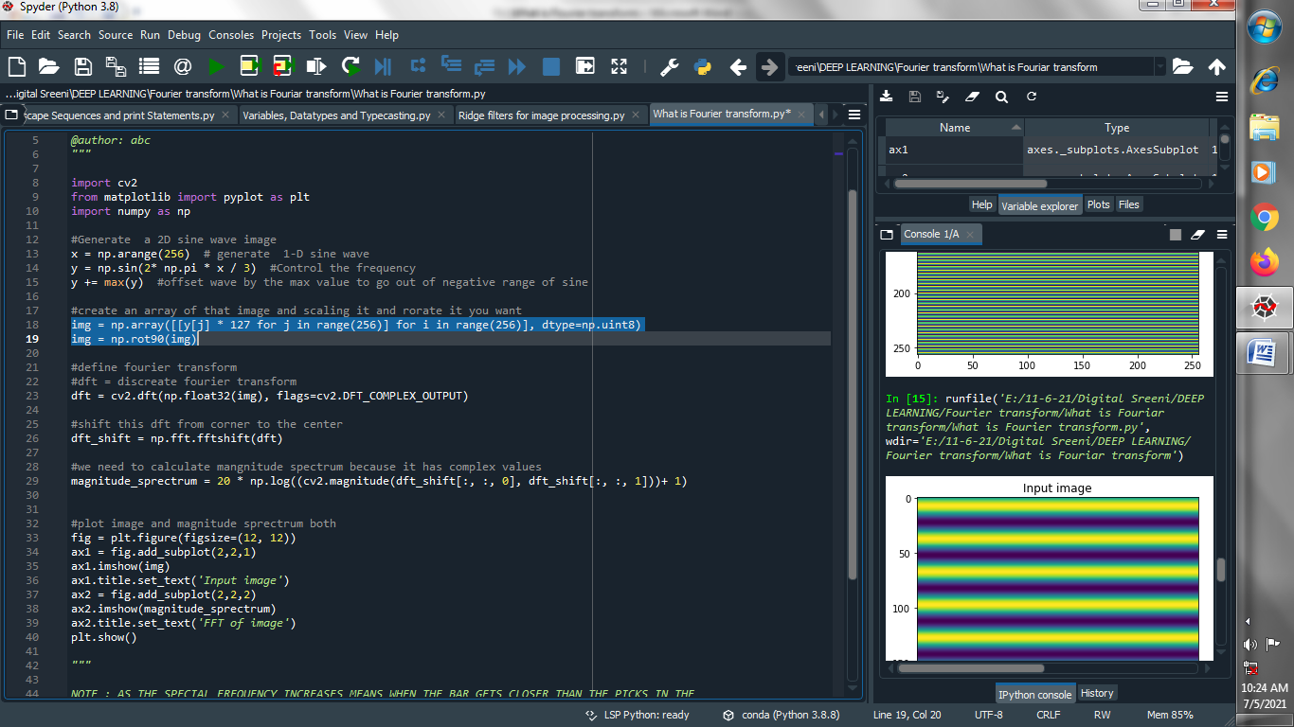

1. **Define fourier transform :**

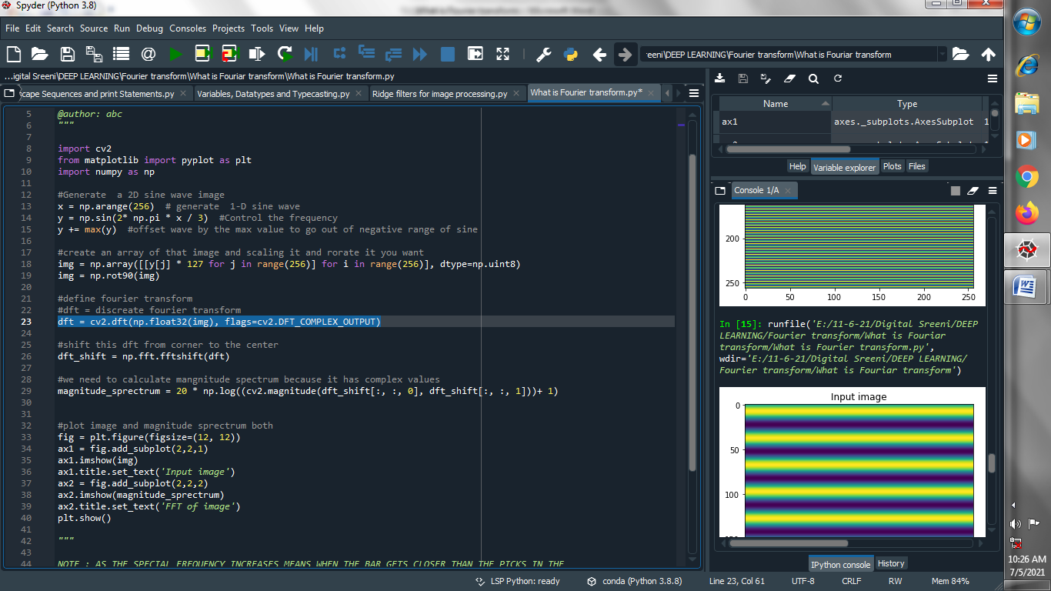

**(4) Shift this dft from corner to center :**

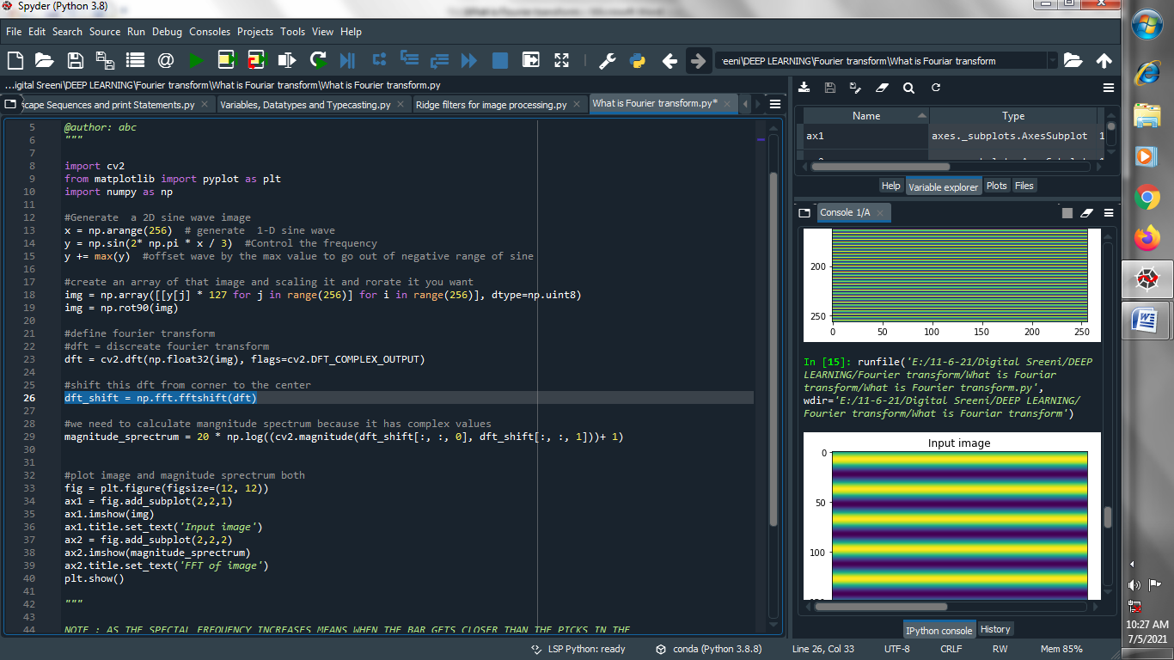

1. **we need to calculate magnitude spectrum because it has complex values .**

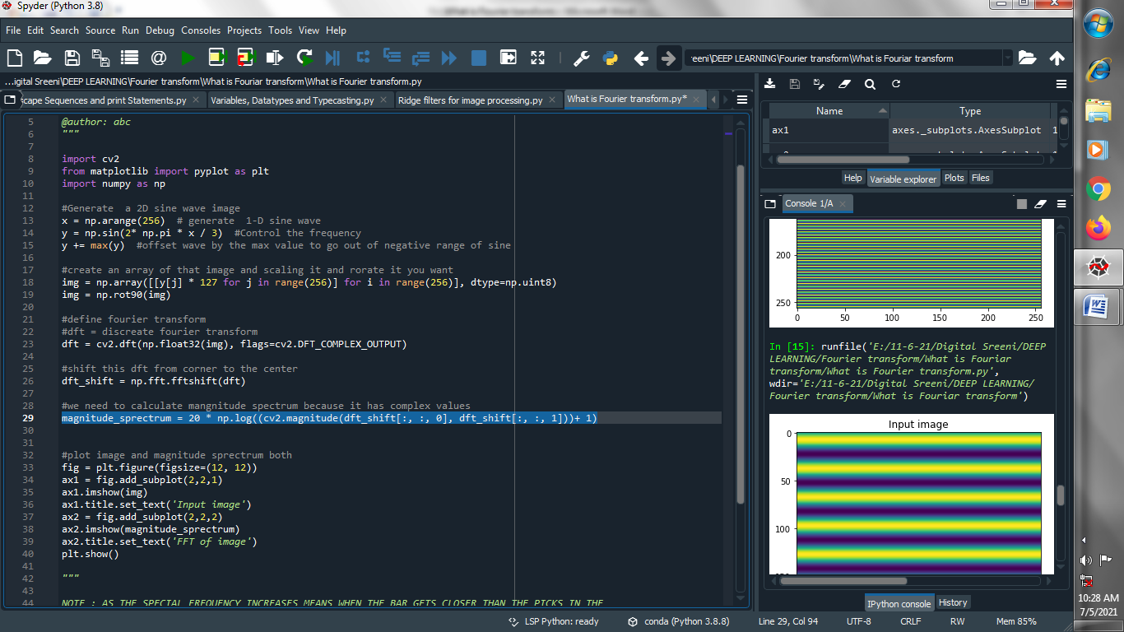

1. **Plot both image and magnitude spectrum :**

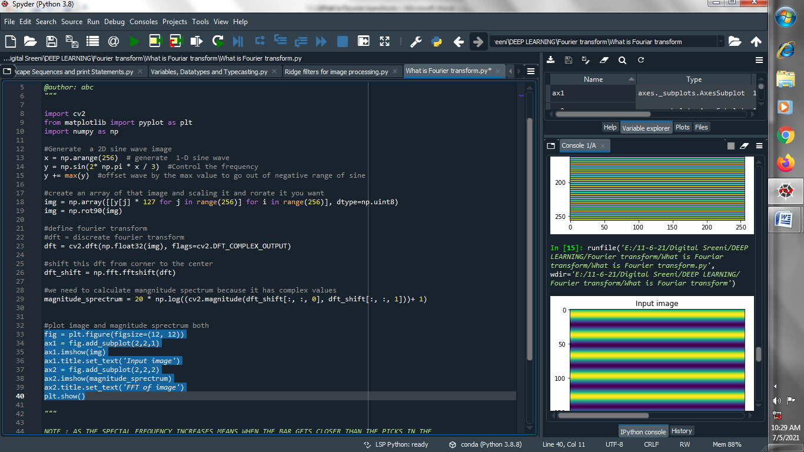

**Output :**

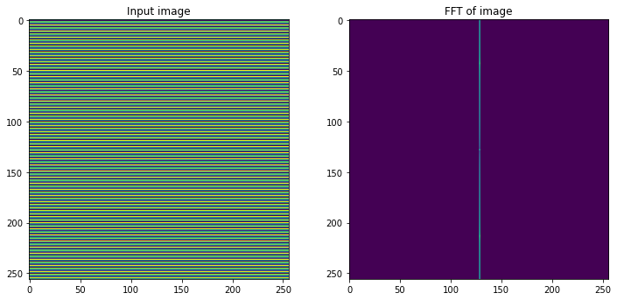

**Let’s increase the frequency :**

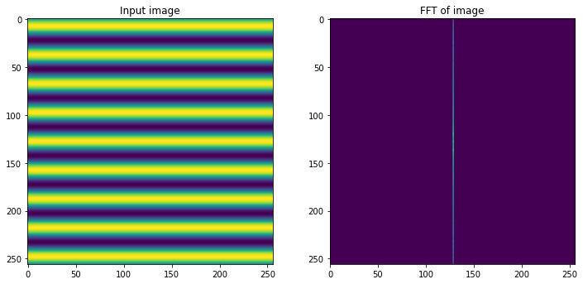

**→ Let’s perform above all things using real world image :**

1. **Read our image :**

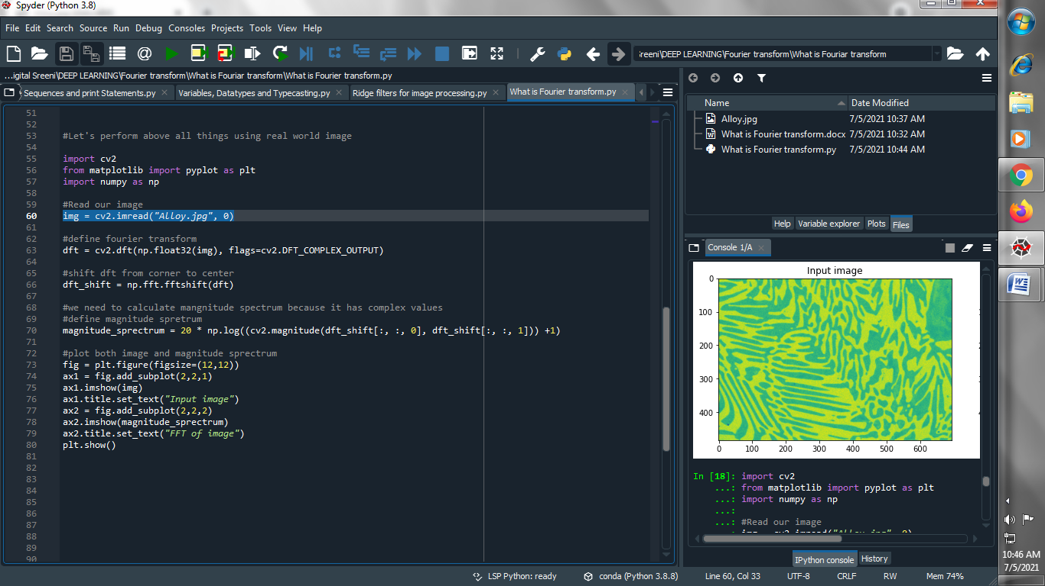

1. **Define fourier transform :**

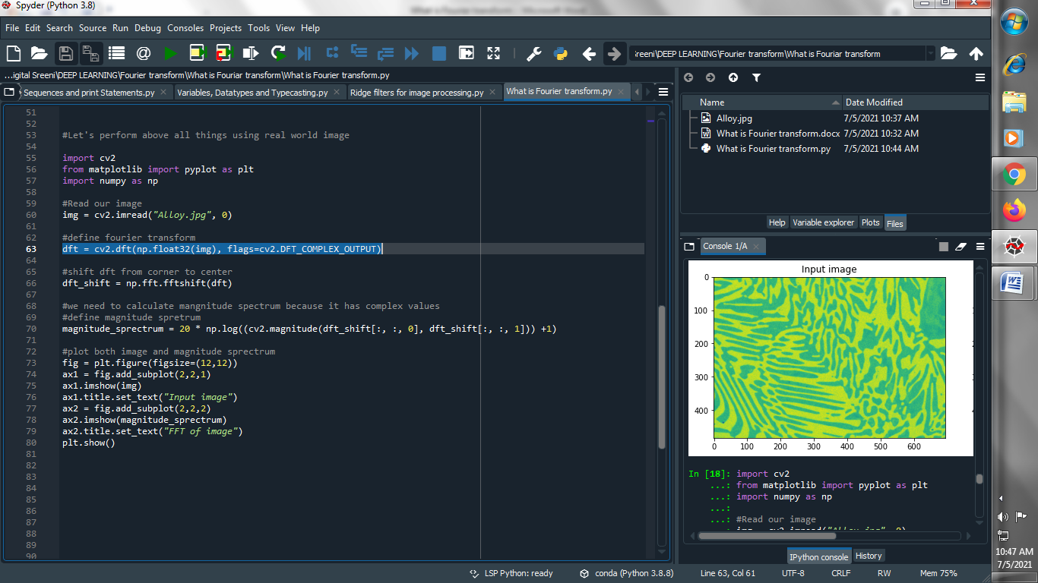

1. **Shift dft(discreate fourier transform) from corner to center :**

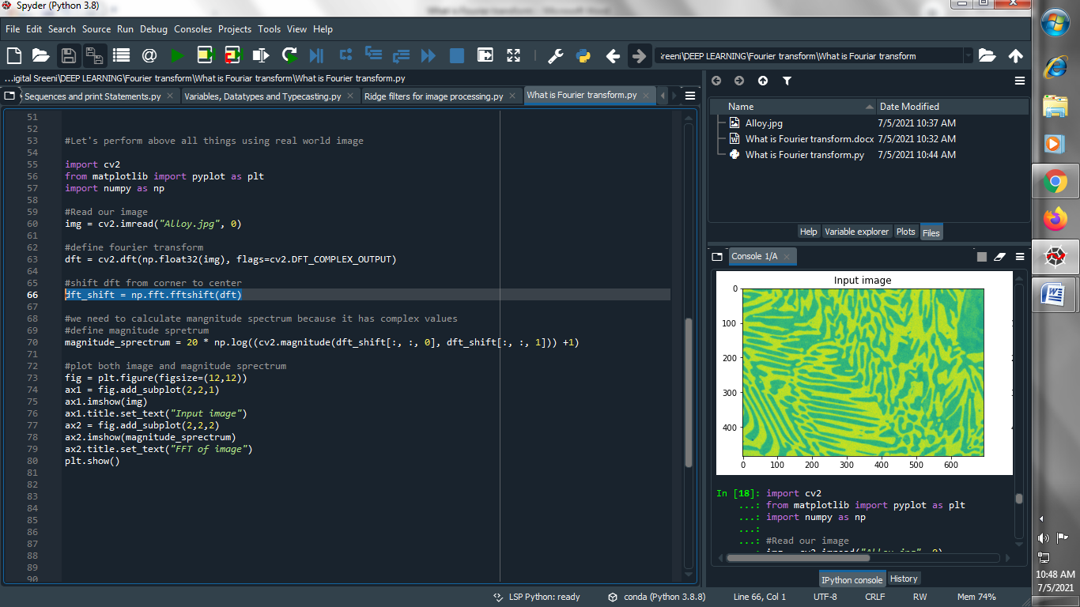

1. **Define magnitude sprectrum :**

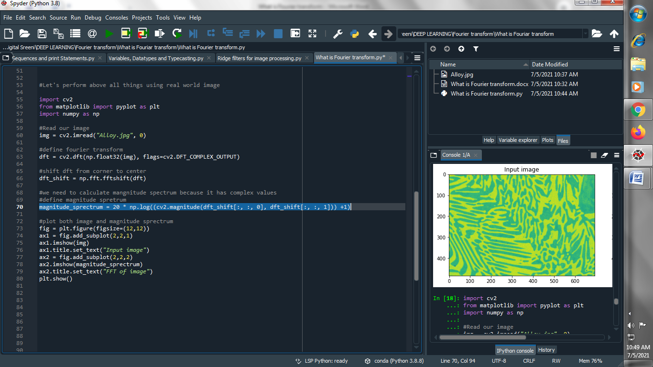

1. **Plot both image and magnitude sprectrum :**

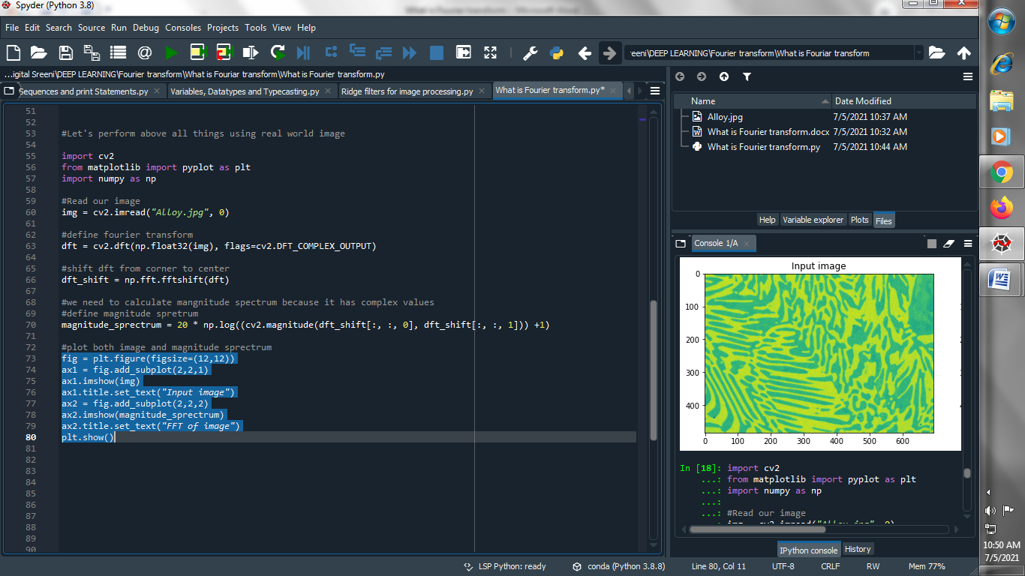

**Output :**

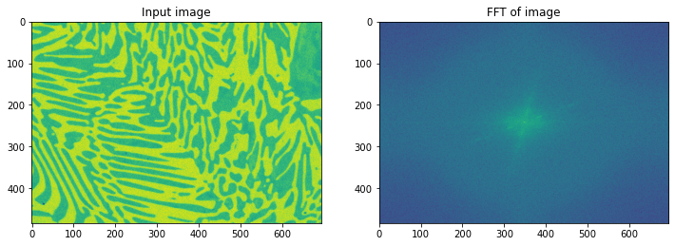

**→ Perform above thing on one more image for better understanding :**

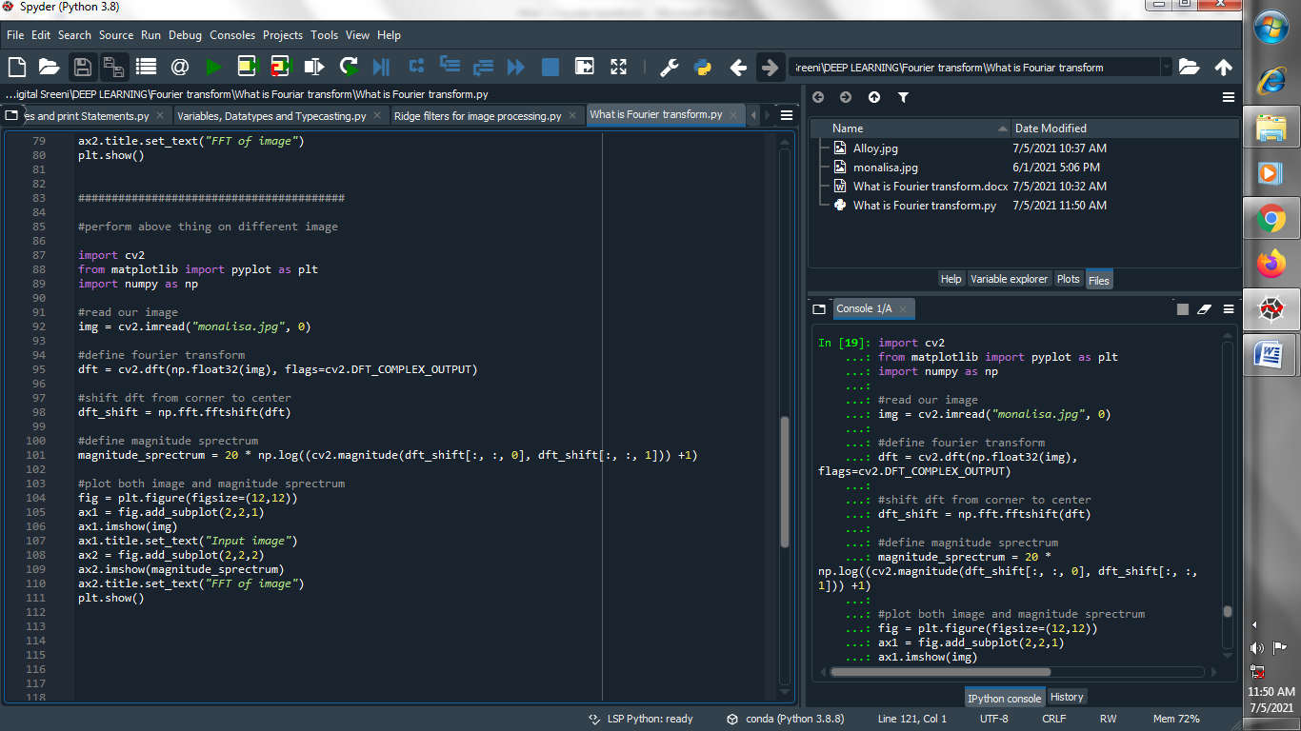

**Output :**

